ITT-216- Access Control List Configuration

Professor: Tim Collins
Course: ITT-216 Enterprise Route & Switch
Student: Liela Pressley
Date: 4/23/2023
Title: Access Control List Configuration

- Ensure that admin PC successfully pings DHCP server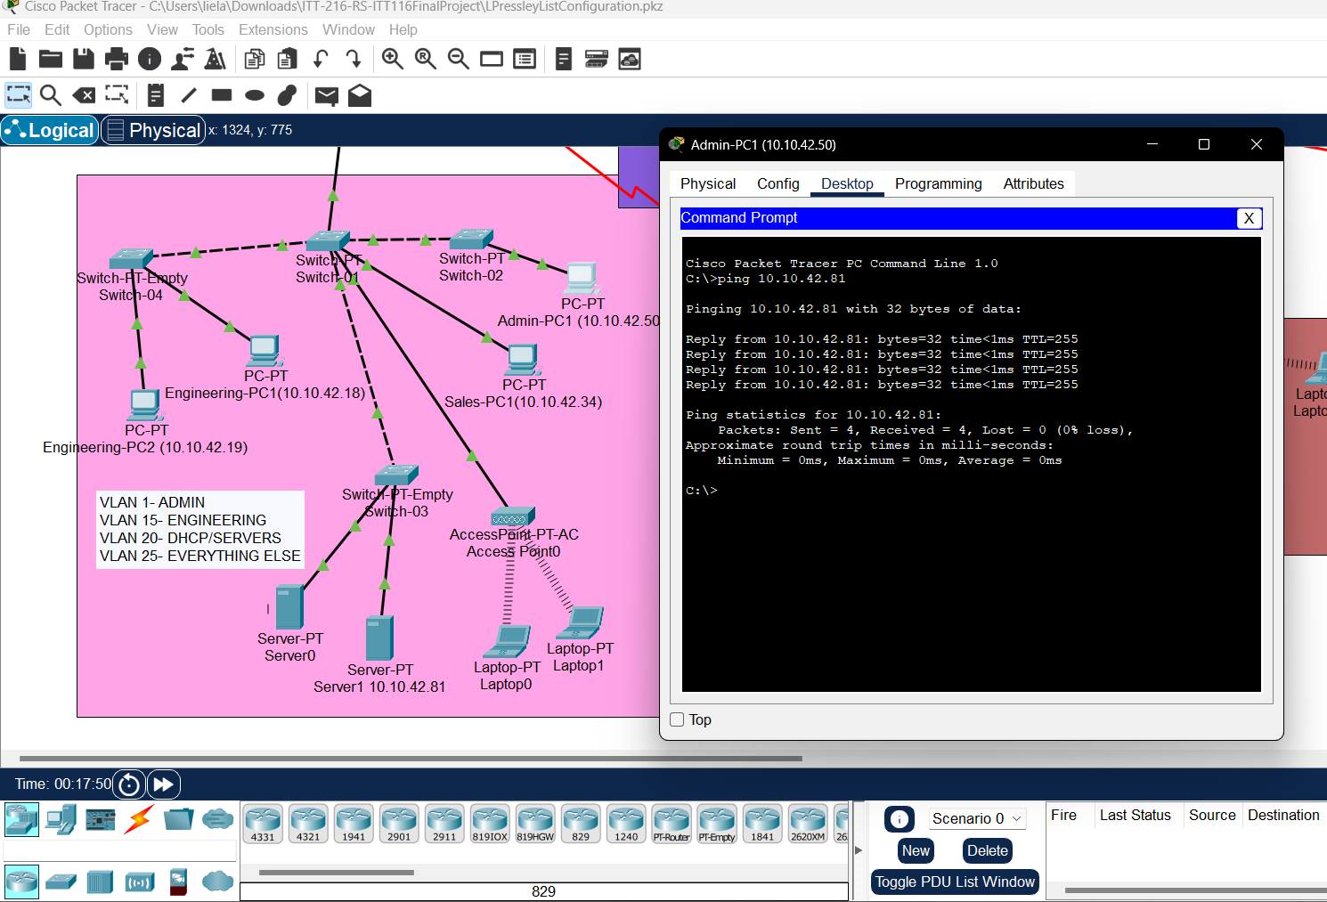
- Ping -t to DHCP server to have it ping continuously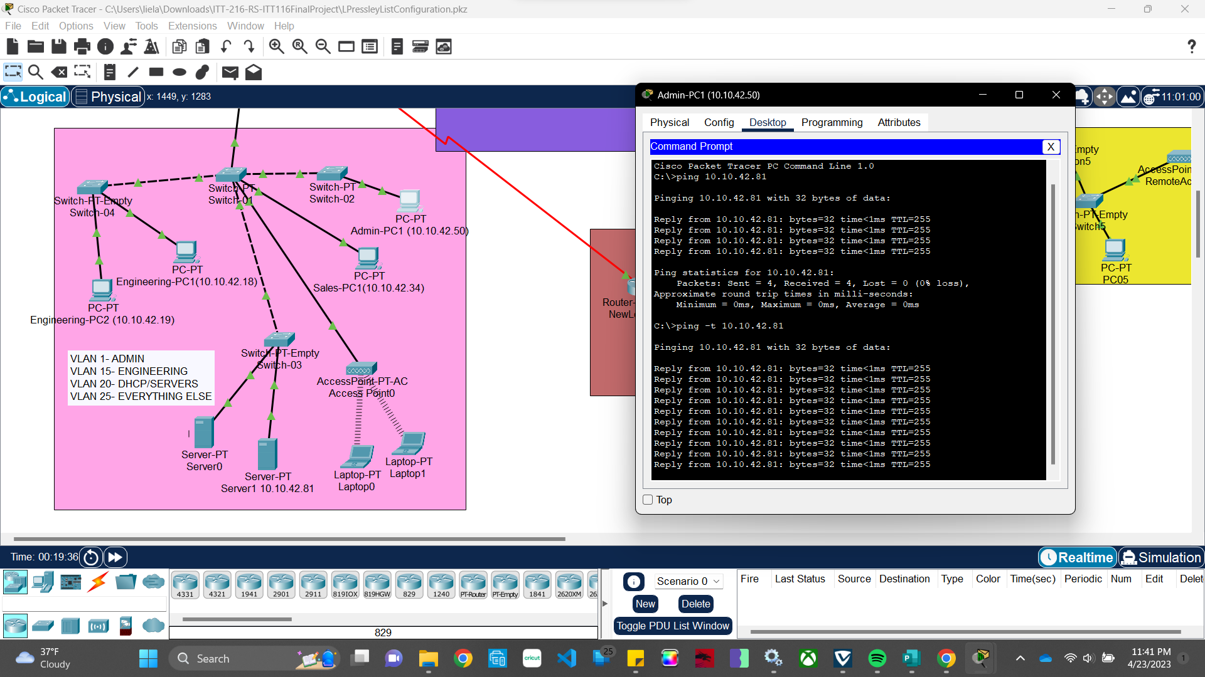
- First configuration commands and still didn’t break the ping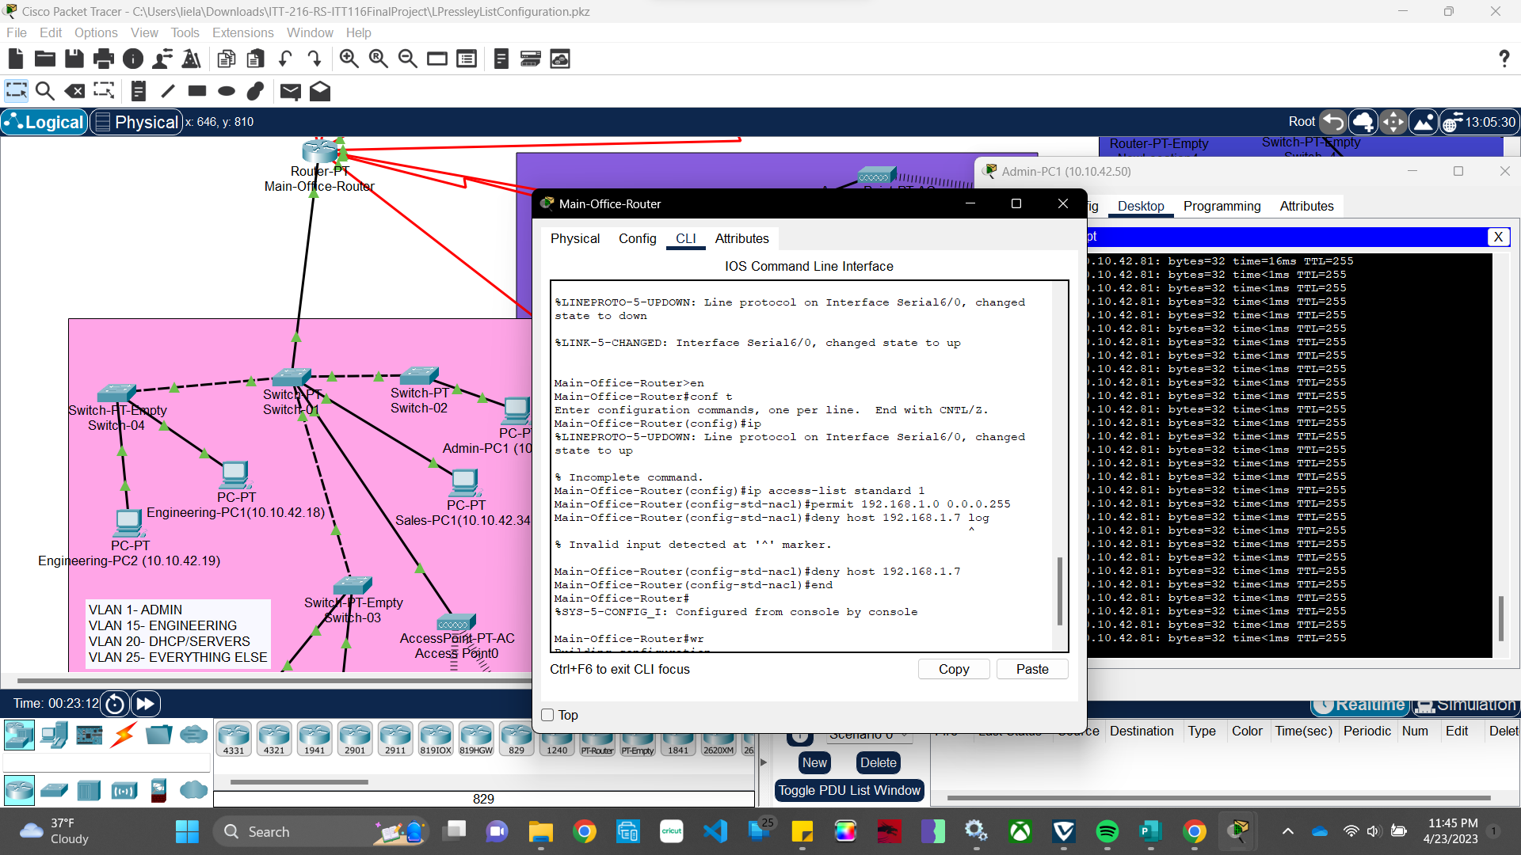
- Pinging successfully after creating an extended ACL list but not applying it yet.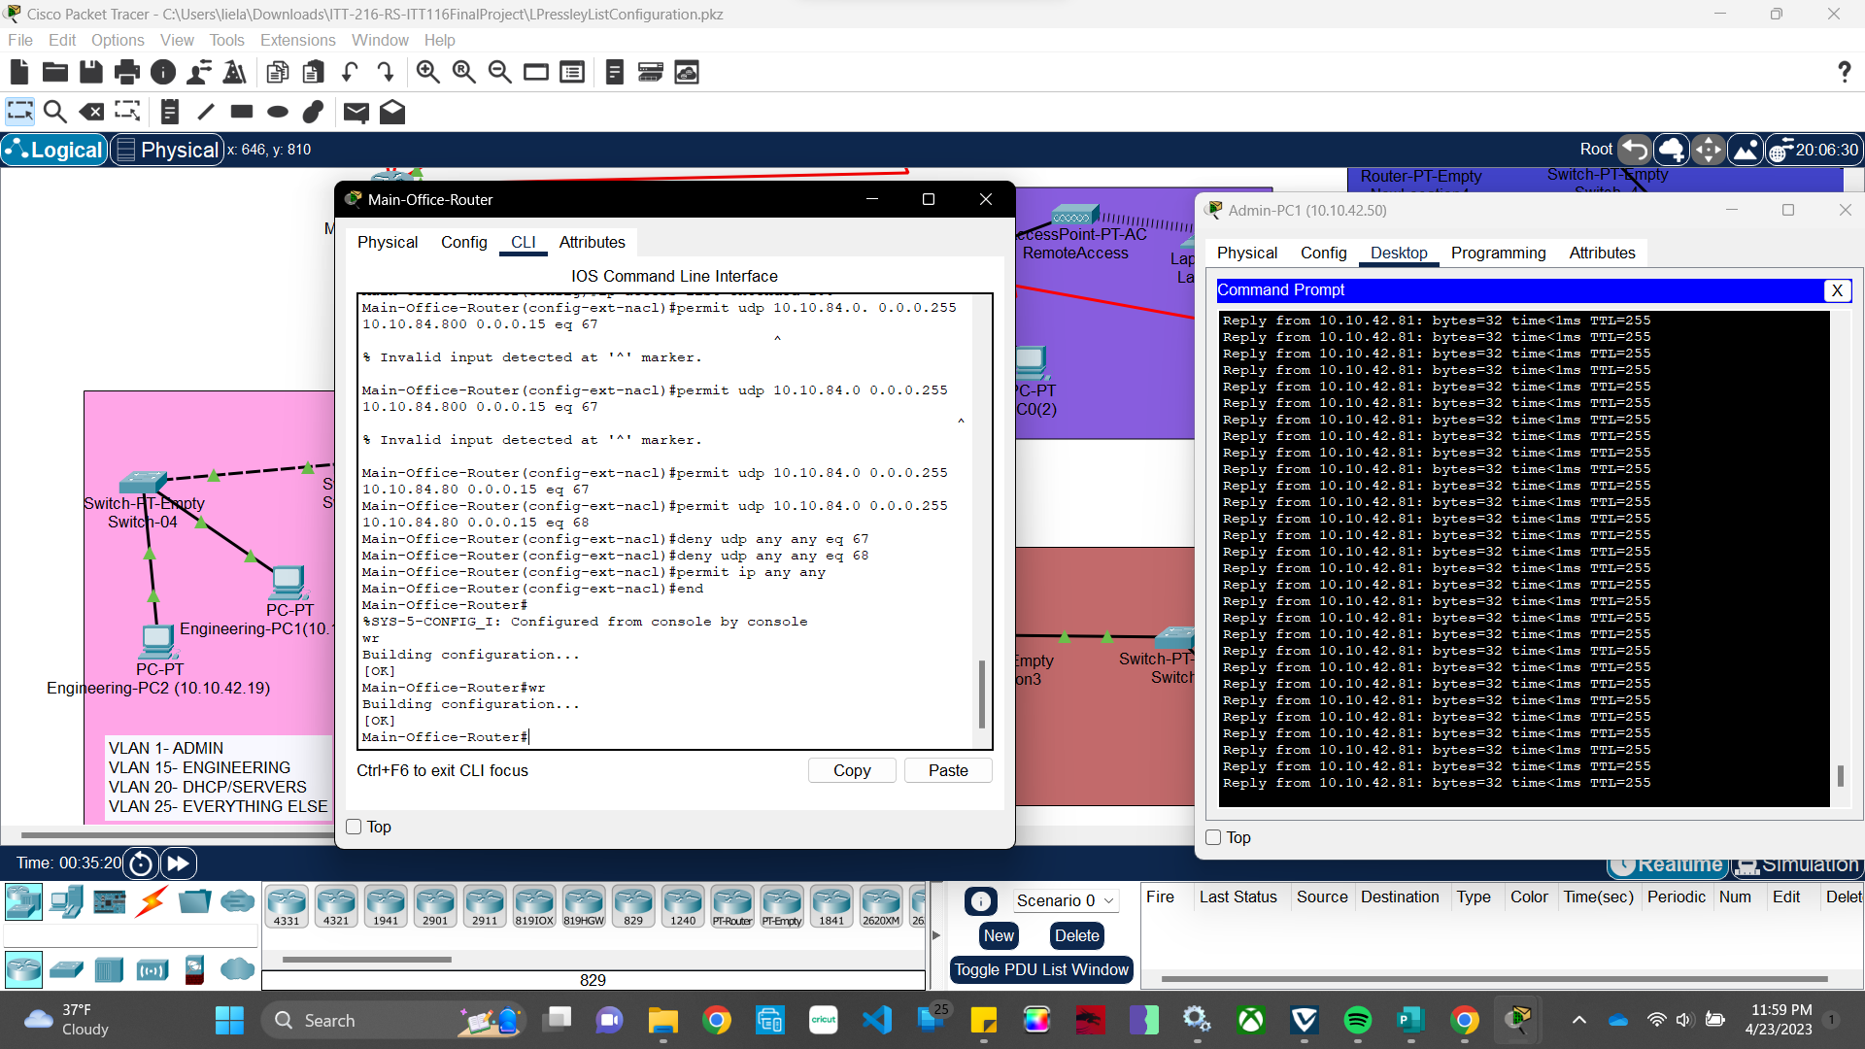
- 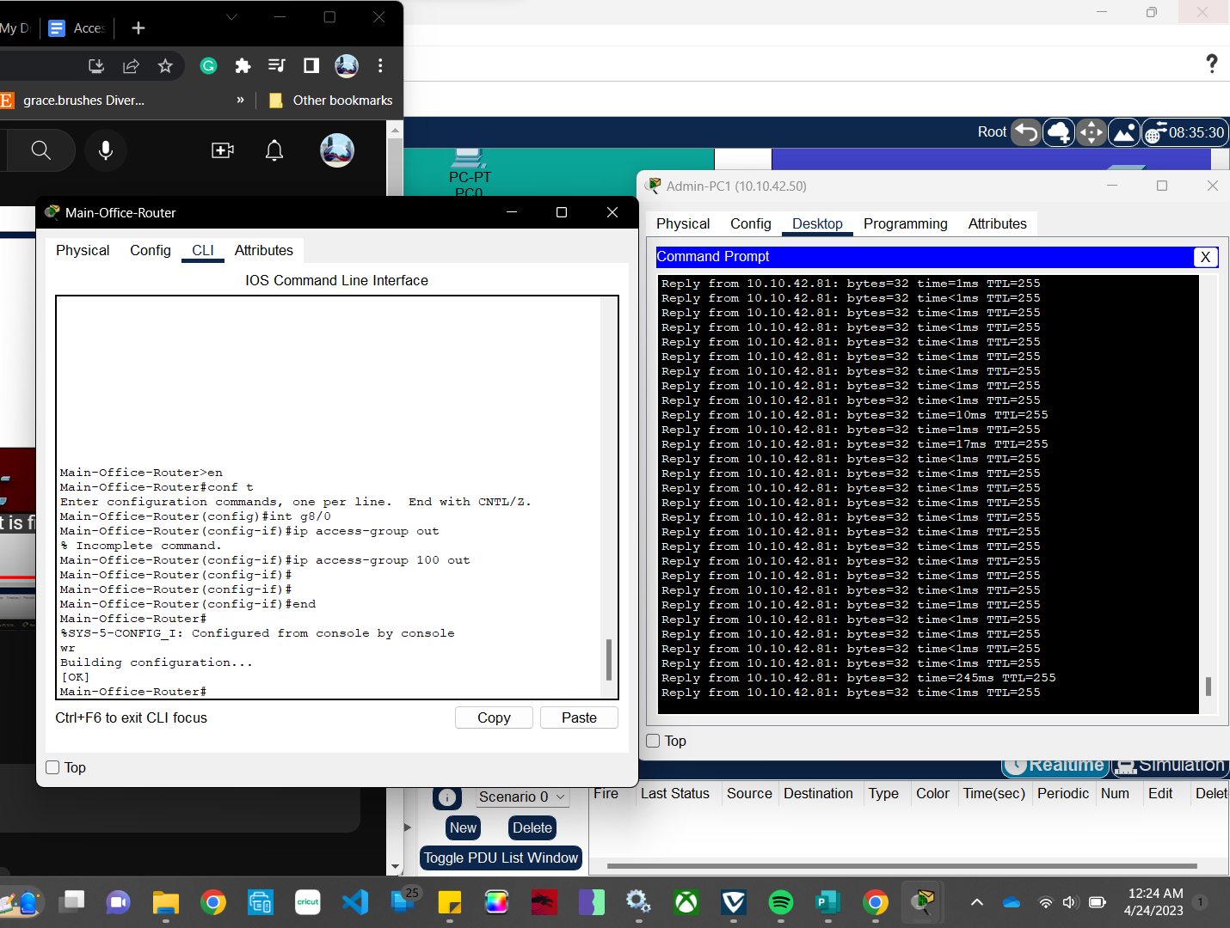
- After applying the ping was supposed to be unsuccessful, but it still went through even though I utilized the right port.